Aurora's Higher Education and Research Academy
Uppal, Hyderabad, Telangana, +91 9100123456, aurora.edu.in
DEPARTMENT OF COMPUTER SCIENCE AND ENGINEERING (ARTIFICIAL INTELLIGENCE AND MACHINE LEARNING)
COMPREHENSIVE PROJECT REPORT

INTERNSHIP - I

PROJECT TITLE
ECSTASY- EVENT PRODUCTION MANAGEMENT SYSTEM
UNDET THE GUIDANCE OF THE TECHNICAL TEAM :
NAME | ROLL NO. | MOBILE NO. | EMAIL
Md. Muzammil Ahmed | 251U1R2015 | +91 8279770342 | muzammilahmedmkj@gmail.com
Shiva Kartikeya Chitta | 251U1R1021 | +91 9030612888 | sivakarthikeyachitta@gmail.com
Vivek Ratanparke | 251U1R1028 | +91 8121851652 | vivek19126@gmail.com
Jayavardhan Nalluri | 251U1R1012 | +91 7013424849 | jayavardhannalluri8@gmail.com
Gugulothu Sandeep | 251U1R2078 | +91 9347504965 | gugulothusandeep5187@gmail.com
Akula Praveen | 251U1R2003 | +91 7981779432 | akulapraveenkumar19@gmail.com
Sai Charan Reddy Vanga | 251U1R1015 | +91 7093351342 | luckyreddyvanga@gmail.com
Teja Kunchala | 251U1R1008 | +91 9391966301 | tejakunchalateja@gmail.com
ADITYA KOUSHIK ADUSUMILLI (Sr Gen AI and Agentic AI Engineer),
BUNNY BOBBALI (Sr Gen AI and Agentic AI Engineer)
R KALYAN (Python Full-Stack Developer),
RAJI TEJA MEDISETTY(Sr Java-mern Developer)
TEAM CRUISERS:
Aurora's Higher Education and Research Academy
Uppal, Hyderabad, Telangana, +91 9100123456, aurora.edu.in

DEPARTMENT OF COMPUTER SCIENCE AND ENGINEERING – AIML

DECLARATION BY THE CANDIDATE

I, Md. Muzammil Ahmed bearing Registration Number 251U1R2015, hereby declare that the project report entitled “ECSTASY- Event Production Management System” under the guidance of the Technical Team, Quality Thought School of Technology , Ameerpet is submitted in partial fulfillment of the requirements for the award of the degree of B.Tech in Computer Science and Engineering – AIML.

This is a record of Bonafide work carried out by me and the results embodied in this project have not been reproduced or copied from any source. The results embodied in this project report have not been submitted to any other university or institute for the award of any other degree or diploma.
Name: Md. Muzammil Ahmed
Reg. No.: 251U1R2015
Aurora's Higher Education and
Research Academy
Uppal, Hyderabad
Aurora's Higher Education and Research Academy
Uppal, Hyderabad, Telangana, +91 9100123456, aurora.edu.in

CERTIFICATE

This is to certify that the Comprehensive Project report entitled “ECSTASY- Event Production Management System” submitted by Mr. Md. Muzammil Ahmed bearing Registration Number 251U1R2015 for the fulfillment of the successful completion of Internship - I in I Year IV Term of B. Tech Program at Aurora’s Higher Education and Research Academy, is an authentic compilation of his efforts, completed under our guidance. We also commend their dedication and effort.

Internal Co-ordinator Head of the Dept External Examiner

ACKNOWLEDGMENT

I am very pleased to present this major Project report. This period of my student life has been truly rewarding several people were of immense help to me during my research and the preparation of my Comprehensive project report.
First, I wish to thank God Almighty who created the heavens and earth and helped me in completing this project.
I thank my parents who encouraged me to continue my Undergraduate studies, to my father and mother.
I would like to thank the Technical Team, Quality Thought School of Technology , Ameerpet for their guidance and help. Their insight during the course of my research and regular guidance was valuable to me.
And also, I thank Mr. Ramprasad , CEO, Quality Thought School of Technology , Ameerpet for his encouragement and cooperation throughout the project.
I would also thank Mr. Ramana Bhupathi , Founder, Quality Thought School of Technology , for extending his help.

ABSTRACT
Ecstasy is a modern event production management web application developed using React JS and FastAPI. The project is designed to provide users with an interactive and visually immersive platform for exploring event services, submitting booking requests, and connecting with the production team. The application includes features such as user authentication, Three.js particle animations, event booking management, portfolio showcase, review carousel, and a contact information system.
The rapid growth of the digital events industry has increased the demand for interactive and responsive web platforms for event production companies. Modern clients expect visually striking interfaces, smooth navigation, dynamic content presentation, and seamless booking experiences. Traditional event company websites often suffer from poor visual identity, limited interactivity, and manual booking processes, which reduce client engagement and overall professionalism.
The proposed project, Ecstasy, is a modern full-stack event production management application developed using React JS for the frontend and FastAPI with PostgreSQL for the backend. The application is designed using a component-based architecture that improves maintainability, scalability, and frontend performance. Modern UI design techniques including WebGL particle systems, scroll reveal animations, cursor aura effects, and reusable React components are implemented to provide a high-energy, brand-consistent user experience. Secure user authentication with bcrypt password hashing and automated welcome email delivery through the Resend API ensures data protection and professional client communication.
The project focuses on improving full-stack development practices while demonstrating concepts such as REST API design, relational database management, component-based architecture, and immersive frontend design. Ecstasy can be further enhanced by integrating payment gateways, admin dashboards, real-time notifications, and advanced analytics features. The proposed system provides a strong foundation for modern event production platform development and helps clients experience smooth and engaging event exploration using advanced web technologies.

SNO. | CONTENT | PAGE NUMBER
1 | Introduction | 1
1.1 | Background Knowledge | 1
1.2 | Motivation for the project | 2
1.3 | Existing System | 3
1.4 | Problem Statement | 4
1.5 | Objectives of the proposed Model | 5
1.6 | Limitations | 6
2 | Literature Survey | 7
2.1 | State of the proposed model | 8
3 | Project Requirements | 10
3.1 | Software requirements | 10
3.2 | Hardware Requirements | 10
3.3 | Functional requirements | 11
3.4 | Non-functional requirements | 12
4 | Project Design | 13
4.1 | System Architecture | 13
4.2 | Architecture Diagram | 14
4.3 | Database Design | 14
4.4 | Database Tables | 15
5 | Methodology | 16
6 | Coding | 19
6.1 | Introduction | 19
6.2 | Frontend Implementation | 19
6.3 | Backend Implementation | 20
6.4 | Database Implementation | 20
6.5 | Authentication module | 21
6.6 | Booking Module | 21
6.7 | Welcome Email Module | 22
6.8 | Password Encryption | 22
6.9 | Three.js Animation | 23
7 | Testing and results | 24
7.1 | Introduction | 24
7.2 | Test Cases | 24
7.3 | Sample outputs | 25
7.4 | Discussion on results | 27
8 | Creativity and Innovation | 28
9 | Community Impact | 29
10 | References | 30
INDEX

1. INTRODUCTION
1.1 BACKGROUND KNOWLEDGE
The event management industry has evolved significantly with the rapid growth of digital technologies. Traditional event planning methods relied heavily on manual registrations, physical documentation, telephone communication, and face-to-face interactions. These approaches often resulted in delays, scheduling conflicts, data redundancy, and poor customer experience. As events became larger and more complex, managing attendees, bookings, and communication manually became increasingly inefficient.
Modern web technologies have transformed the way event management organizations operate. Online platforms now allow customers to browse available services, register securely, book events, receive instant confirmations, and communicate with organizers through digital channels. Automation has reduced human effort while improving accuracy and operational efficiency.
The Ecstasy Event Production Management System is a web-based application developed to simplify event booking and customer management. It provides a modern interface where users can register, log in securely, and book various types of events through an intuitive dashboard. The application integrates frontend and backend technologies to ensure secure authentication, efficient database management, and seamless communication.
The frontend of the system is developed using React.js with Vite, providing a responsive and interactive user interface. Three.js is incorporated to create visually appealing particle animations that enhance user engagement. The backend is developed using FastAPI, which offers high performance for RESTful API development. PostgreSQL serves as the relational database, while SQLAlchemy manages database interactions using Object Relational Mapping (ORM). Passwords are encrypted using bcrypt hashing, ensuring secure storage of user credentials. Automated welcome emails are sent using the Resend Email API after successful user registration.
1.2 MOTIVATION FOR THE PROJECT
The primary motivation behind developing the Ecstasy Event Production Management System was to eliminate the inefficiencies associated with manual event booking processes. During conventional event management, customers often face difficulties in contacting organizers, confirming bookings, tracking requests, and receiving timely updates. Organizers, on the other hand, spend considerable effort managing customer records, maintaining booking details, and responding to repetitive queries.
With the increasing adoption of web applications, users expect a seamless online experience that allows them to register, authenticate, and book services instantly. Existing manual systems fail to meet these expectations, resulting in customer dissatisfaction and reduced operational productivity.
This project was undertaken to provide a centralized digital platform that simplifies customer interaction while maintaining high standards of security and usability. The inclusion of password encryption, email notifications, responsive design, and interactive animations enhances the overall user experience. The project also provided practical exposure to full-stack web development using modern technologies, making it an ideal academic and real-world implementation.

1.3 EXISTING SYSTEM
Most traditional event management organizations rely on manual booking procedures or partially digital systems that require extensive human intervention. Customers generally communicate with organizers through telephone calls, email exchanges, or physical visits to confirm bookings. Event details are frequently maintained using spreadsheets or handwritten records, making the management process time-consuming and error-prone.
Commercial event management platforms such as Eventbrite offer comprehensive booking services but primarily focus on ticket sales for public events. These platforms often include subscription costs and limited customization options, making them unsuitable for organizations seeking personalized event production solutions.
The limitations of existing systems include:
- Manual customer registration.
- Lack of secure authentication.
- Poor booking management.
- No automated email notifications.
- Increased possibility of duplicate records.
- Limited customization.
- Higher operational costs.
These drawbacks emphasize the need for an integrated web-based solution that simplifies event management while maintaining security and efficiency.

1.4 PROBLEM STATEMENT
Traditional event booking methods suffer from inefficient customer management, manual record maintenance, lack of secure authentication, and poor communication between customers and organizers. Manual operations increase administrative workload and introduce errors in maintaining booking information.
Customers expect modern web platforms that provide secure registration, quick login, real-time booking, and immediate confirmation of successful operations. Existing approaches fail to deliver these capabilities effectively.
Therefore, there is a need for a secure, user-friendly, and automated Event Production Management System capable of streamlining customer registration, authentication, booking management, and communication through a centralized web application.

  - OBJECTIVES OF THE PROPOSED MODEL
The primary objective of the Ecstasy Event Production Management System is to develop a secure and responsive web application that automates event booking and customer management processes.
Specific objectives include:
- To develop an interactive user interface using React.js.
- To build RESTful APIs using FastAPI.
- To implement secure user authentication.
- To encrypt user passwords using bcrypt.
- To maintain customer and booking records using PostgreSQL.
- To automate welcome email notifications using Resend API.
- To provide responsive design across different devices.
- To improve overall customer experience through interactive animations.
- To minimize manual intervention in booking management.
- To provide an efficient platform for event organizers.

  - LIMITATIONS
Although the proposed system satisfies the major functional requirements, certain limitations remain.
- Google Authentication has not been integrated.
- Payment gateway functionality is not implemented.
- Admin dashboard is not available.
- Booking approval process is manual.
- SMS notifications are not supported.
- Event cancellation and refund features are not included.
- The application currently supports only a single organization.
Despite these limitations, the system successfully demonstrates a secure and scalable architecture suitable for event production management.

2. LITERATURE SURVEY
The development of web-based event management systems has received significant attention due to the increasing demand for online booking platforms. Various technologies have contributed toward improving customer experience, application security, and operational efficiency.
Eventbrite is one of the widely used commercial platforms that enables users to browse, register, and purchase event tickets online. Although comprehensive, it primarily focuses on ticketing services and provides limited customization for private event production companies.
React.js has emerged as one of the most popular frontend frameworks due to its component-based architecture and efficient rendering mechanism. React allows developers to create reusable UI components, improving maintainability and reducing development time.
FastAPI has gained popularity for backend development because of its exceptional performance, automatic API documentation, asynchronous request handling, and simple syntax. It provides an efficient framework for building scalable REST APIs.
PostgreSQL remains one of the most reliable relational database management systems. Its support for ACID properties, indexing, transactions, and data integrity makes it suitable for enterprise-grade applications.
SQLAlchemy simplifies communication between Python applications and relational databases by implementing Object Relational Mapping. Developers can manipulate database objects using Python classes rather than writing raw SQL queries.
bcrypt is widely adopted for password hashing due to its adaptive hashing algorithm and built-in salting mechanism, making stored passwords resistant to brute-force attacks.
Three.js enhances user interfaces by enabling interactive 3D graphics and particle animations within web browsers. Such visual enhancements improve user engagement without requiring additional plugins.
The Resend Email API provides a modern solution for sending transactional emails. It simplifies email integration and supports automated notifications after successful user registration.

2.1 STATE OF THE PROPOSED MODEL
The rapid advancement of information technology has transformed event management from manual operations into fully automated digital platforms. Modern event management systems emphasize security, scalability, responsiveness, and automation to improve customer satisfaction and organizational efficiency. Cloud computing, RESTful APIs, relational databases, and modern JavaScript frameworks have become the standard technologies for developing event booking applications.
Current commercial systems such as Eventbrite, Cvent, and Ticketmaster provide online booking, ticket management, and customer registration facilities. Although these systems offer extensive functionality, they are primarily designed for large-scale commercial events and often require subscription fees. Small event production companies frequently require customized solutions tailored to their business processes.
The proposed Ecstasy Event Production Management System adopts a client-server architecture that combines React.js for frontend development, FastAPI for backend services, PostgreSQL for database management, SQLAlchemy ORM for database operations, bcrypt for password encryption, and Resend API for automated email notifications. The application provides secure authentication, responsive interfaces, automated booking management, and improved user experience through Three.js animations.
Unlike traditional systems, the proposed model integrates modern web technologies into a lightweight and highly responsive application suitable for both desktop and mobile environments.

Table 2.1 Literature Survey
Author/Technology | Contribution | Limitation
Eventbrite | Online booking and ticket management | Commercial platform with subscription costs
React.js Documentation | Component-based UI development | Frontend only
FastAPI Documentation | High-performance backend framework | Requires separate database integration
PostgreSQL Documentation | Relational database management | Database only
SQLAlchemy Documentation | Simplifies ORM operations | Requires schema definition
bcrypt Documentation | Password encryption | Authentication only
Resend Documentation | Automated email notifications | Free plan limits recipients
Three.js Documentation | Interactive animations | Increased frontend complexity

3. PROJECT REQUIREMENTS
3.1 SOFTWARE REQUIREMENTS
1) Operating System: Windows 10/11
•2) Python: 3.11+
•3) FastAPI: Latest
•4) React.js: 19
•5) Vite: Latest
•6) PostgreSQL: 16
•7) SQLAlchemy: Latest
•8) Visual Studio Code: Latest
- Google Chrome: Latest
- Postman: Latest
3.2 HARDWARE REQUIREMENTS
1) Processor: Intel Core i5 or above
•2) RAM: 8GB minimum
•3) Storage: 256GB SSD
•4) Internet: Broadband connection
•5) Monitor: 1920 x 1080 Resolution
  - FUNCTIONAL REQUIREMENTS
The proposed system performs several important functions that allow users to interact with the application efficiently.
The functional requirements include:
- User Registration
- Secure Login using Username or Email
- Password Encryption
- Event Booking
- Database Storage
- Welcome Email Notification
- Responsive User Interface
- Booking Form Validation
- Logout Functionality
- Secure REST API Communication
User Registration: The system allows new users to create an account by providing their name, username, email address, password, and password confirmation. Validation ensures duplicate usernames and email addresses are not allowed.
User Login: Registered users can authenticate using either their username or email address along with their password. Passwords are verified using bcrypt hashing.
Booking Module: Authenticated users can book different event types including concerts, parties, stand-up shows, corporate events, and cyphers by providing booking details.
Email Notification: Upon successful registration, the application automatically sends a welcome email using the Resend Email API.
Database Management: All user credentials and booking information are securely stored in PostgreSQL through SQLAlchemy ORM.
3.4 NON-FUNCTIONAL REQUIREMENTS
The system also satisfies several non-functional requirements that improve usability and maintainability.

Performance: FastAPI enables high-speed API processing with low response times.

Security: Passwords are encrypted using bcrypt before storage. Sensitive information is never stored in plain text.

Reliability: PostgreSQL ensures ACID compliance and maintains data consistency.

Scalability: The modular architecture allows additional features such as payment gateways and admin dashboards to be integrated easily.

Usability: The React-based interface is simple, responsive, and visually attractive.

Maintainability: The project follows modular programming practices, making future maintenance straightforward.

4. PROJECT DESIGN:
4.1 SYSTEM ARCHITECTURE:
The Ecstasy Event Production Management System follows a three-tier architecture consisting of the presentation layer, application layer, and database layer.
The presentation layer is developed using React.js and communicates with the backend through REST APIs. The application layer is implemented using FastAPI, which processes requests, performs validation, handles authentication, and interacts with the database. The database layer consists of PostgreSQL, where customer and booking records are securely maintained.
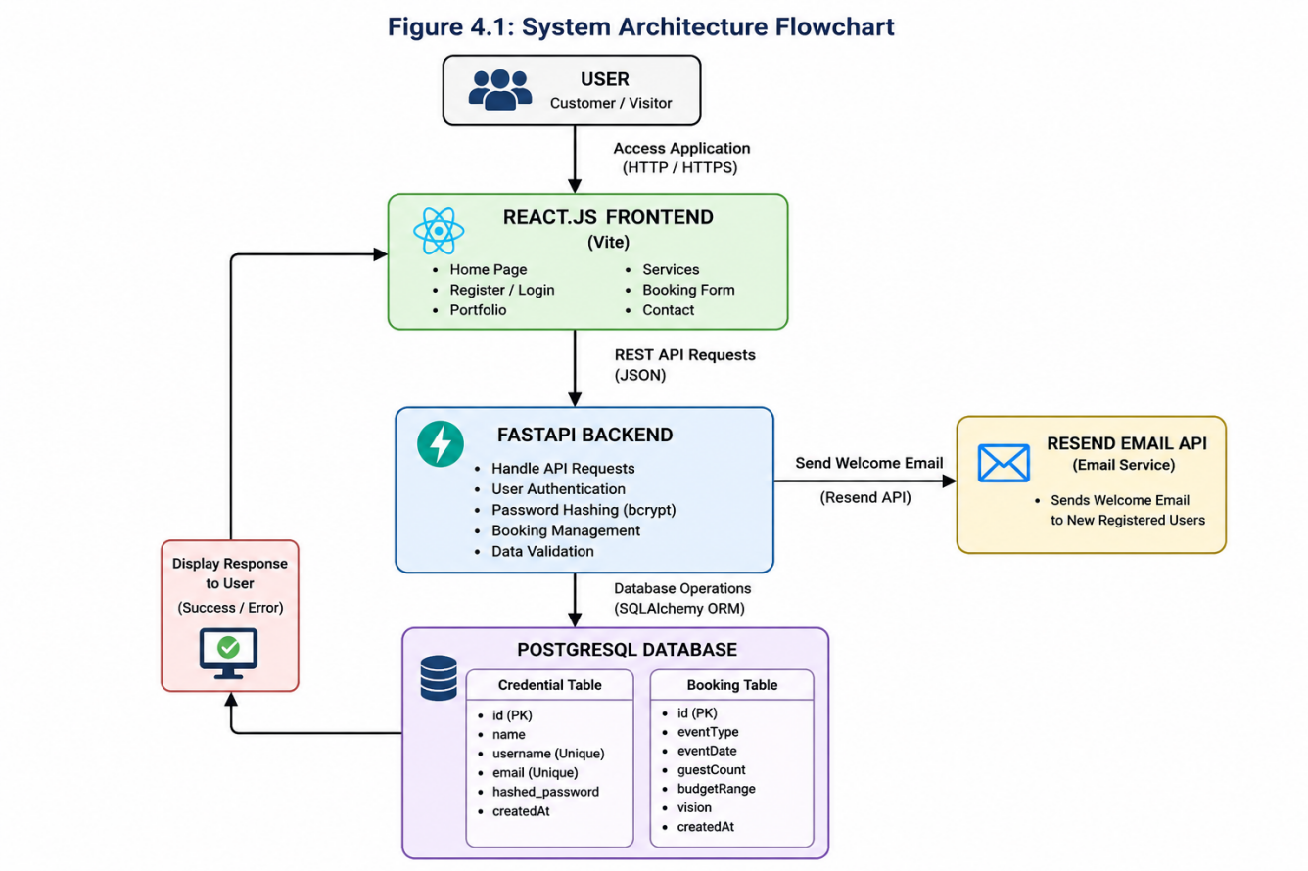
4.2 DATABASE DESIGN
The database consists of two primary tables:
Credential Table Stores user information.
Fields include: ID, Name, Username, Email, Hashed Password and CreatedAt
Booking Table Stores customer booking information.
Fields include: Booking ID ,Event Type, Event Date, Guest Count ,Budget Range, Vision and CreatedAt
4.3 API DESIGN
The backend exposes REST APIs for communication between frontend and backend.
Method | Endpoint | Description
GET | / | Home API
POST | /api/auth/register | Register User
POST | /api/auth/login | Login User
POST | /api/bookings | Create Booking
GET | /api/bookings | Retrieve Bookings
4.4 AUTHENTICATION FLOW:
The authentication module follows the following sequence:
- User enters registration details.
- Password is encrypted using bcrypt.
- User information is stored in PostgreSQL.
- Welcome email is sent.
- User logs in using username or email.
- Backend verifies encrypted password.
- User gains access to the application.

5. METHODOLOGY:
The Ecstasy Event Production Management System follows an incremental software development methodology. Each module was designed, developed, tested, and integrated independently before combining into the final application.
The methodology consists of the following stages:
Requirement Analysis: The project requirements were collected by analyzing traditional event booking systems and identifying their limitations. Functional and non-functional requirements were documented before implementation.
System Design: The application architecture, database schema, API structure, and user interface were designed before coding.
Frontend Development: The frontend was developed using React.js with reusable components. CSS was used to create responsive layouts, while Three.js was integrated to display animated particle effects on the landing page.
Backend Development: FastAPI was used to implement REST APIs responsible for user authentication and booking management. SQLAlchemy ORM handled communication between Python and PostgreSQL.
Database Integration: The Credential and Booking tables were created using SQLAlchemy models. CRUD operations were implemented through FastAPI endpoints.
Authentication: The authentication module validates user credentials, encrypts passwords using bcrypt, and allows login using either username or email.
Email Integration: The Resend API automatically sends a welcome email after successful user registration.
Testing Each module was tested independently before integration testing. Functional testing verified authentication, booking creation, email delivery, and database operations.
Workflow:
Start
↓
Register User
↓
Encrypt Password
↓
Store in Database
↓
Send Welcome Email
↓
User Login
↓
Verify Credentials
↓
Dashboard
↓
Book Event
↓
Store Booking
↓
Success Message
↓
End

6. CODING
6.1 INTRODUCTION:
The Ecstasy Event Production Management System was implemented using a full-stack architecture consisting of React.js for the frontend and FastAPI for the backend. PostgreSQL was used as the relational database, while SQLAlchemy provided Object Relational Mapping (ORM). Password encryption was implemented using bcrypt, and automated welcome emails were sent using the Resend Email API.
The coding structure follows a modular approach, where each component performs a specific task, improving maintainability and scalability.
6.2 FRONTEND IMPLEMENTATION:
The frontend was developed using React.js with Vite. React enables the creation of reusable components and dynamic rendering based on user interactions. The application interface includes the landing page, authentication forms, event booking module, portfolio section, and responsive navigation.
The landing page integrates Three.js to display animated particle effects, providing an engaging user experience. React Hooks such as useState, useEffect, and useRef manage component states and lifecycle events efficiently.
Major Frontend Modules:
- Landing page
- User Registration
- User Login
- Event Booking Form
- Portfolio Display
- Navigation Bar
- Contact Section and footer
6.3 BACKEND IMPLEMENTATION:
The backend was implemented using FastAPI, which provides high-performance RESTful APIs. FastAPI handles incoming HTTP requests, validates user data, performs authentication, and communicates with the PostgreSQL database.
The backend consists of the following API endpoints:
HTTP Method Endpoint Purpose GET / Backend Status POST /api/auth/register User Registration POST /api/auth/login User Authentication POST /api/bookings Create Booking GET /api/bookings Retrieve Booking Details The backend uses dependency injection provided by FastAPI to establish database connections securely.
6.4 DATABASE IMPLEMENTATION:
The PostgreSQL database stores all user credentials and booking information.
Two tables were created:
Credential Table Field Description id Primary Key name Customer Name username Unique Username email Email Address hashed_password Encrypted Password createdAt Registration Date
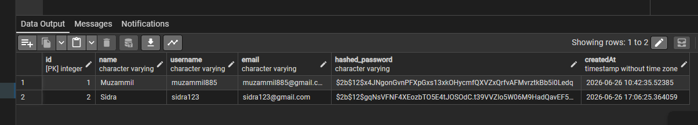
Booking Table Field Description id Booking ID eventType Selected Event eventDate Date of Event guestCount Number of Guests budgetRange Estimated Budget vision Customer Requirements createdAt Booking Date
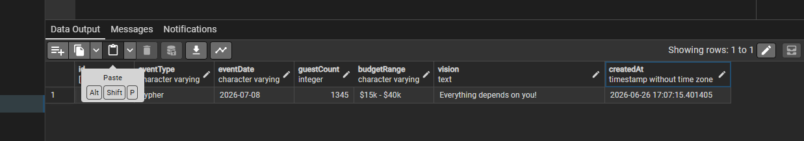
6.5 AUNTHENTICATION MODULE:
The authentication module ensures that only registered users can access the booking system.
The process involves:
- User Registration
- Password Encryption
- Database Storage
- User Login
- Password Verification
- Session Authentication
Passwords are encrypted using bcrypt before storage, preventing unauthorized access even if the database is compromised.
6.6 BOOKING MODULE:
The booking module enables authenticated users to submit booking requests.
The booking form collects:
- Event Type
- Event Date
- Guest Count
- Budget Range
- Event Vision
The submitted data is validated by FastAPI before being stored in PostgreSQL.
6.7 WELCOME EMAIL MODULE:
Upon successful registration, the backend invokes the Resend Email API to send a welcome email.
The email contains:
- Welcome Message
- Customer Name
- Company Branding
- Website Link
This automation improves customer engagement immediately after account creation.
6.8 PASSWORD ENCRYPTION:
The application uses bcrypt hashing provided by Passlib.
Advantages include:
- Password salting
- Secure hash generation
- Protection against brute-force attacks
- No plaintext password storage
6.9 THREE.JS ANIMATION:
The homepage includes animated particles created using Three.js.
Features include:
- Dynamic particle rendering
- Interactive visual effects
- Lightweight animation
- Improved user experience

7. TESTING AND RESULTS
7.1 INTRODUCTION
Testing ensures that every module performs according to the specified requirements.
The application was tested using manual testing and API testing through FastAPI.
7.2 TEST CASES
Test Case | Expected Result | Status
Register New User | Account created | Pass
Duplicate Username | Error message | Pass
Duplicate Email | Error message | Pass
Login with username | Success | Pass
Login with Email | Success | Pass
Wrong Password | Invalid credentials | Pass
Create booking | Booking stored | Pass
Welcome email | Email sent | Pass
Retrieve bookings | Records displayed | Pass

7.3 SAMPLE OUTPUTS:
Registeration:
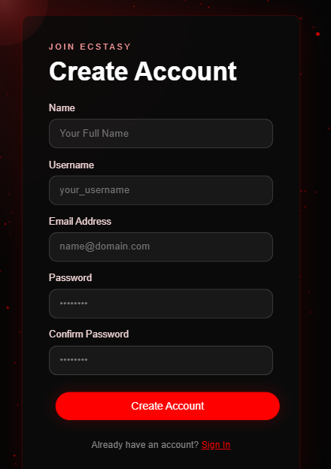
Login:
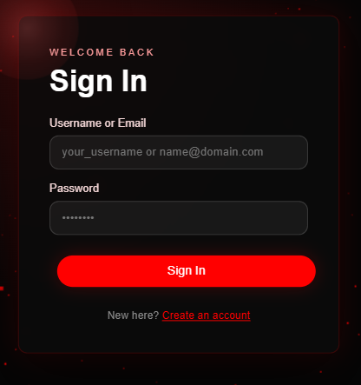
Booking:
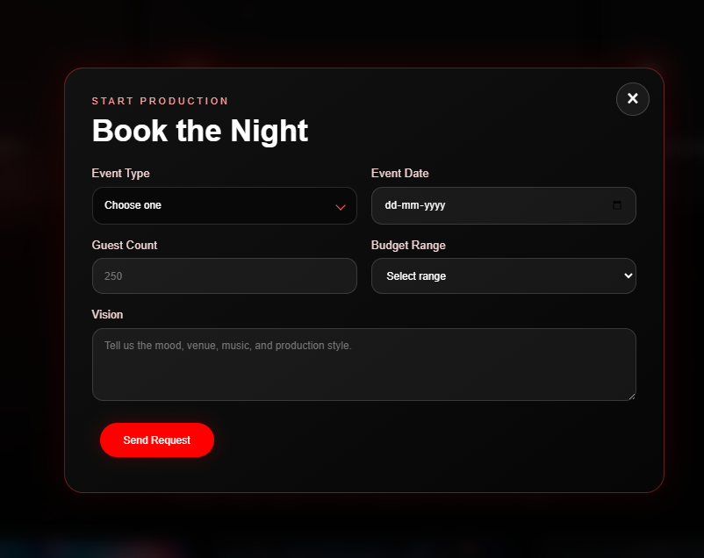
Welcome Email:
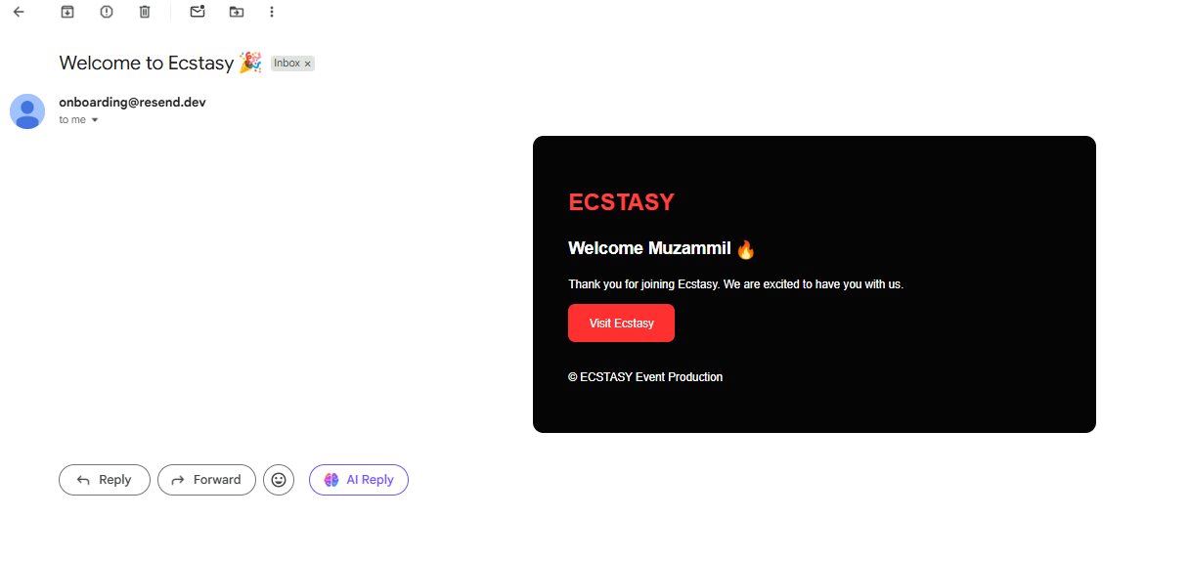
PostgreSQL Database:
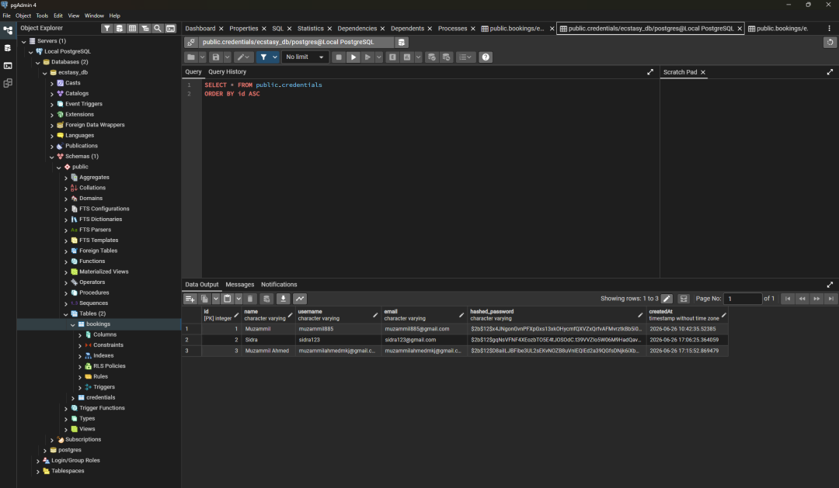
7.4 DISCUSSION ON RESULTS
The developed application successfully satisfied all functional requirements.
Major observations include:
- Secure registration
- Login using username or email
- Password encryption
- Booking storage
- Responsive UI
- Successful API communication
- Database consistency
- Automated welcome emails
The system performed efficiently during testing without any major failures.

8. CREATIVITY & INNOVATION
The Ecstasy Event Production Management System incorporates several innovative features that distinguish it from conventional event booking applications.
The homepage integrates Three.js particle animations, providing an immersive user experience. The authentication system allows users to log in using either their username or email address, improving usability. Password encryption using bcrypt ensures strong security for stored credentials. Automated welcome emails using the Resend Email API enhance customer engagement immediately after successful registration.
The modular architecture enables future integration of payment gateways, Google authentication, QR code ticketing, analytics dashboards, and mobile applications

9. COMMUNITY IMPACT
The proposed system benefits both customers and event organizers.
Customers can securely register, log in, and submit bookings without visiting the organization physically. Organizers benefit from centralized customer management, reduced paperwork, and automated communication.
The system encourages digital transformation in small and medium-sized event production companies and can be extended for educational institutions, cultural organizations, conference management, and entertainment industries.
Future enhancements may include:
- Google Authentication
- Online Payments
- Admin Dashboard
- SMS Notifications
- QR Code Tickets
- Event Analytics
- Mobile Application

- REFERENCES

- https://react.dev/

- https://fastapi.tiangolo.com/

- https://www.postgresql.org/docs/

- https://docs.sqlalchemy.org/

- https://passlib.readthedocs.io/

- https://github.com/pyca/bcrypt

- https://www.geeksforgeeks.org/reactjs/reactjs-projects/ https://threejs.org/docs/

- https://resend.com/docs

- https://developer.mozilla.org/

- https://docs.python.org/3/

